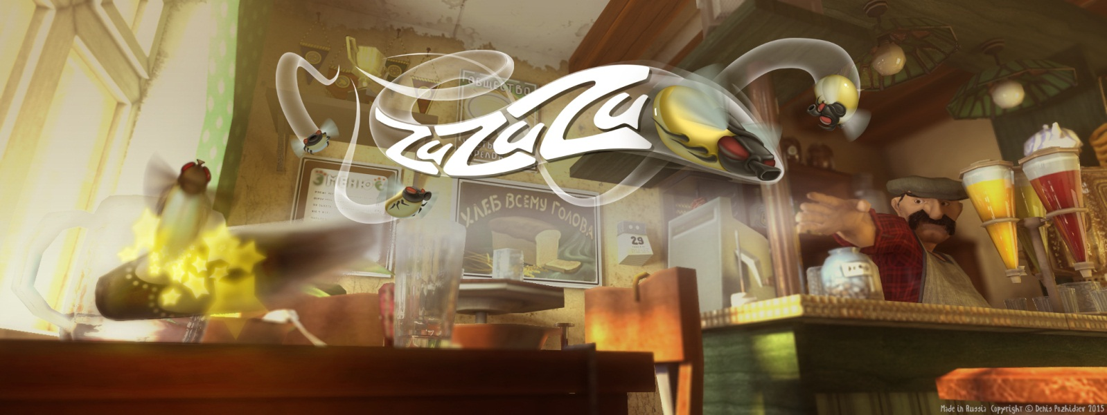
A free destructive flyshooter ‘ZuZuZu’
will be available for download on the App Store and Google Play from February 19.
Under Embargo until February 19, 2016.
Moscow - February 16, 2016 - Denis Pozhidaev, an independent developer of mobile games and applications, jointly with Gennadiy Ovcharenko, an artist, release "ZuZuZu or Flies' invasion in N town" – a new arcade game for iOS and Android. In ZuZuZu a player is to shoot down flies, which swarm the room, with different kinds of shoes. And there’s high probability to destroy something if missed.
Using four game modes, a player can change the rules and set different goals: get rid of flies as accurate as possible, as fast as possible, set a new record or make maximum destruction. The story of ZuZuZu takes place in a little Soviet town N where, according to the storyline, the player helps the local policeman to investigate the reason of this massive invasion of flies. New rooms are unlocked during the gameplay. From a kitchen and an entry room to the shop of a slipper factory and the hall of a paleontological museum. "The collecting of generalized impressions of the Soviet way of life and remaking them in a comedian way, like Leonid Gayday's films, has become the main purposes for Gennadiy Ovcharenko and me, during the period of ZuZuZu design," said Denis Pozhidaev, the developer and co-author. "That's why this game can be interesting not only for children, but also for adults, which are familiar with the late-Soviet lifestyle."
"ZuZuZu or Flies' invasion in N town" will be available for free download on the App Store for iPhone or iPad and on Google Play for Android devices worldwide.
Please visit www.pozhidaev-denis.com/ZuZuZu.html for more ZuZuZu information,
including screenshots and video of the gameplay.
Denis Pozhidaev develops mobile games since 2013. ZuZuZu is his second game. Denis considers his main goals as searching of systems in real-life which can be a foundation for gameplay as well as visualization of the Russian lifestyle through his games.
###
If you are interested to get additional information about ZuZuZu or Ovcharenko's and Pozhidaev's design, please contact: info@pozhidaev-denis.com

